BUCS Competitor Information

Location:
University of Liverpool Sports and Fitness Centre
Bedford St N
Liverpool
L69 7ZN
There is a car park outside the sports centre but car sharing is recommended.
The sports centre is around a 15 minute walk from Liverpool Lime St station.
Events:
BUCS specific events are
- BUCS Championship Open weight Open / women - 2,000m
- BUCS Championship lightweight Open / women - 2,000m
- BUCS Open / Women Sprint - 250m
- BUCS Championship adaptive Open / women - 1,000m
- BUCS Beginner Open / women - 1,000m
These are also open to non-university clubs and competitors and there may be bands based on entries.
Lightweight weights are as follows: Men 75.0kg, Women 61.5kg
This is as per BUCS regulations. Any rower who doesn’t make these weights will be allowed to compete in the open category. Weighing in will take place in the upstairs office at registration.
A beginner is defined as an athlete “who have taken up the sport - on the water (regardless of their discipline) after 1 June of the preceding academic year.” As per the BUCS definition.
Entries are to be done on BUCS Play for universities for the BUCS categories. The deadline for entries is 23:59 on 28th October 2025. The draw will be sent out to clubs on the 31st October 2025.

These are the non-BUCS informal events:
- Relays Open / Women / Mixed - 4x1,000m
- Sprint Relays Open / Women / Mixed – 4x250m
- Sprint Open / Women - 100m
- Coach race - 750m
- Cox race - 500m
- Spectator race (non-rowers only) - 500m
All informal race entries are to be done at registration on the day. There is no cap on relay teams per club. (These events may be changed due to entries)
Entry fees will be £5 pp per race with the exceptions of the relays which will be £15 per team and sprint which is £2. Please pay as a club in one go at registration.
Relays – open to the 3 sub-categories: universities, clubs and non-rowers. Medals will be awarded to each of these subcategories within the 3 categories of men, women and mixed. Mixed relays will comprise of 2 men and 2 women. There is no senior/beginner division for relays, all abilities compete together. No other member is allowed to help with changeovers, this must be done amongst the 4 competitors.
Coaches – You are allowed to compete as both a coach and a rower. There will be a medal for men and women separately. A coach will be classified as someone who coaches a team but does not compete for that team – captains do not classify.
Coxes – You are allowed to compete as both a cox and a rower. To classify as a cox, you must have cox points on British Rowing and have coxed/be entered to cox for this season. There will be a medal for men and women separately.
Spectators – This is open to anyone who is not member of any rowing club. We will be teaching the basic erg pattern to anyone who wants to compete in the lunch break. Please bring friends/family with you to give it a go! There will be a medal for men and women separately.

Provisional Program: 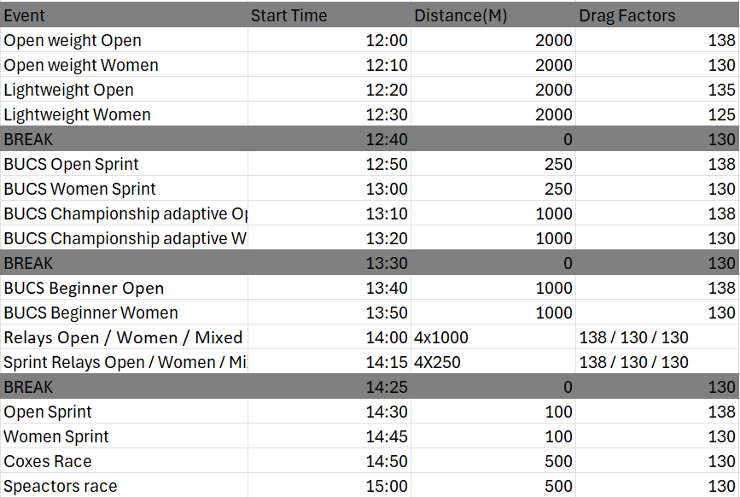
All timings are subject to change based on entries.
Drag factors are set according to BUCS regulations and will be set and checked before the race starts. You must not change these.
Races will be done in waves of 8 competitors.
Competitors must be in the hall, in the waiting zone 15 minutes before their race time.
All athletes must register for the events 30 minutes before event
Please be on time for your event. Arriving late to the waiting zone may result in disqualification.
Warm up / Cool down areas:
We will have a warm up room which will be open for 1 hour before first event This will be equipped with ergs, spin bikes and mats.
There will also be ergs and mats available in the main hall for warm up and cool down.
Additional Information:
There will be food and drink sold at the event.
Medals will be awarded for each category. Any winners of a BUCS race will be sent their medal after the series has finished
Male, female and gender neutral toilets / changing will be available. Lockers will also be available, please keep big bags in here to avoid a safety hazard.
If you can provide volunteers for divisions that you are not in, that would be incredibly helpful!
Contact:
livunibc@googlemail.com
Or our instagram @livunibc
Event Manager, William Mehta: 07902345111
LUBC President, Ryan Joesph: 07985673200

